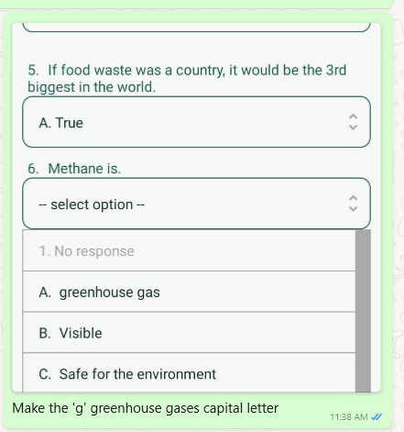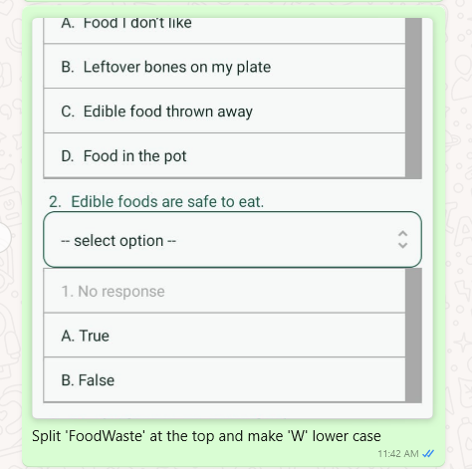

The crossword under food waste causes keep causes the app to shut down